Notice of NTRO11417, Roughton, Thorpe Market
Norfolk County Council proposes to make a Temporary Traffic Regulation Order (the “Order”) (NTRO11417) affecting A) A140 Norwich Road from 140 metres south of its junction with B1436 Thorpe Market road for 350 metres northwards (“Road A”) and B) B1436 Thorpe Market Road from its junction with A140 Norwich Road for 110 metres eastwards (“Road B”) and C) B1436 Chapel Road from its junction with A140 Norwich Road for 30 metres westwards (“Road C”) and D) A149 Cromer Road from 30 metres north of its junction with C289 Thorpe Road for 110 metres southwards (“Road D”) and E) B1436 Roughton Road from its junction with A149 Cromer Road for 50 metres westwards (“Road E”) and F) C289 Thorpe Road from its junction with A149 Cromer Road for 50 metres eastwards (“Road F”) in the Parishes of Roughton and Thorpe Market to facilitate carriageway resurfacing works, the Roads A – F will be temporarily closed/restricted (except for pedestrian access) for the duration of the works/period the closure is necessary which is anticipated to be between 19:00 and 06:00 from 12th to 16th October 2026, but may continue to be closed/restricted until the 27th November 2026 where the closure/restriction is still required beyond the anticipated dates.
NB: These restrictions will take place in phases. Roads A-C will be closed during Phase One between 19:00 and 06:00 from 12th to 16th October 2026, and Roads D-F will be closed during Phase Two between 19:00 and 06:00 from 19th to 22nd October 2026.
Alternative route is via: Road A: A149 North Walsham Road/ Cromer Road, B1145 Greens Road/ Aylsham Road/ North Walsham Road Road B: B1436 Roughton Road, A149 Cromer Road/ North Walsham Road/ Crossdale Street/ Norwich Road/ Mount Street/ Louden Road, A148 West Street/ Holt Road, B1436 Cromer Road/ Roughton Road/ Chapel Road Road C: B1436 Roughton Road/ Cromer Road, A148 Holt Road/ Cromer Road/ West Street, A149 Prince of Wales Road/ Hamilton Road/ Church Street/ Norwich Road/ Crossdale Street, A140 Norwich Road Road D: A149 North Walsham Road/ Cromer Road, B1145 Greens Road/ Aylsham Road/ North Walsham Road Road E: A149 Cromer Road, A140 Norwich Road, B1436 Thorpe Market Road Road F: A149 Cromer Road/ Crossdale Street/ Norwich Road, C491 Cromwell Road, C292 Northrepps Road/ Cromer Road/ Nut Lane/ Craft Lane/ Sandy Lane, C289 Thorpe Road (Roughton, Northrepps, Thorpe Market, Antingham, North Walsham, Felmingham, Colby, Aylsham, Erpingham, Alby with Twaite, Hanworth, Cromer, Felbrigg, Runton).
The works promoter for this restriction/closure is: Norfolk County Council.
Vehicular access will be permitted to a final destination in the Roads A – F where signs indicating such access is possible and permitted are in place.
The Order shall automatically revoke on the completion of the works/when the closure is no longer necessary or otherwise on the 27th November 2026 without further notice.
If necessary, the restriction could run for a maximum period of 18 months from the date the Order is effective.
A person who contravenes, or who uses or permits the use of a vehicle in contravention of the restriction/closure imposed by the Order shall be guilty of an offence.
Penalty: £1000 maximum fine on conviction and/or endorsement for contravention.
In the event of the start date being delayed the new start date will be displayed on site in advance.
Full details on the closure are available at https://one.network. Any enquiries that cannot be answered on the one.network website should be directed to the North Area Streetworks (Infrastructure Department) contactable by telephone at 0344 800 8020 or email at streetworks@norfolk.gov.uk
Dated this 2nd day of October 2026.
Katrina Hulatt
Director of Legal Services (nplaw)
County Hall
Martineau Lane
Norwich
NR1 2DH

Phase One:

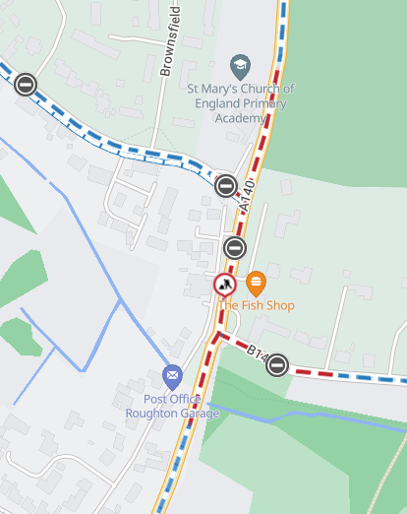

Phase Two:

